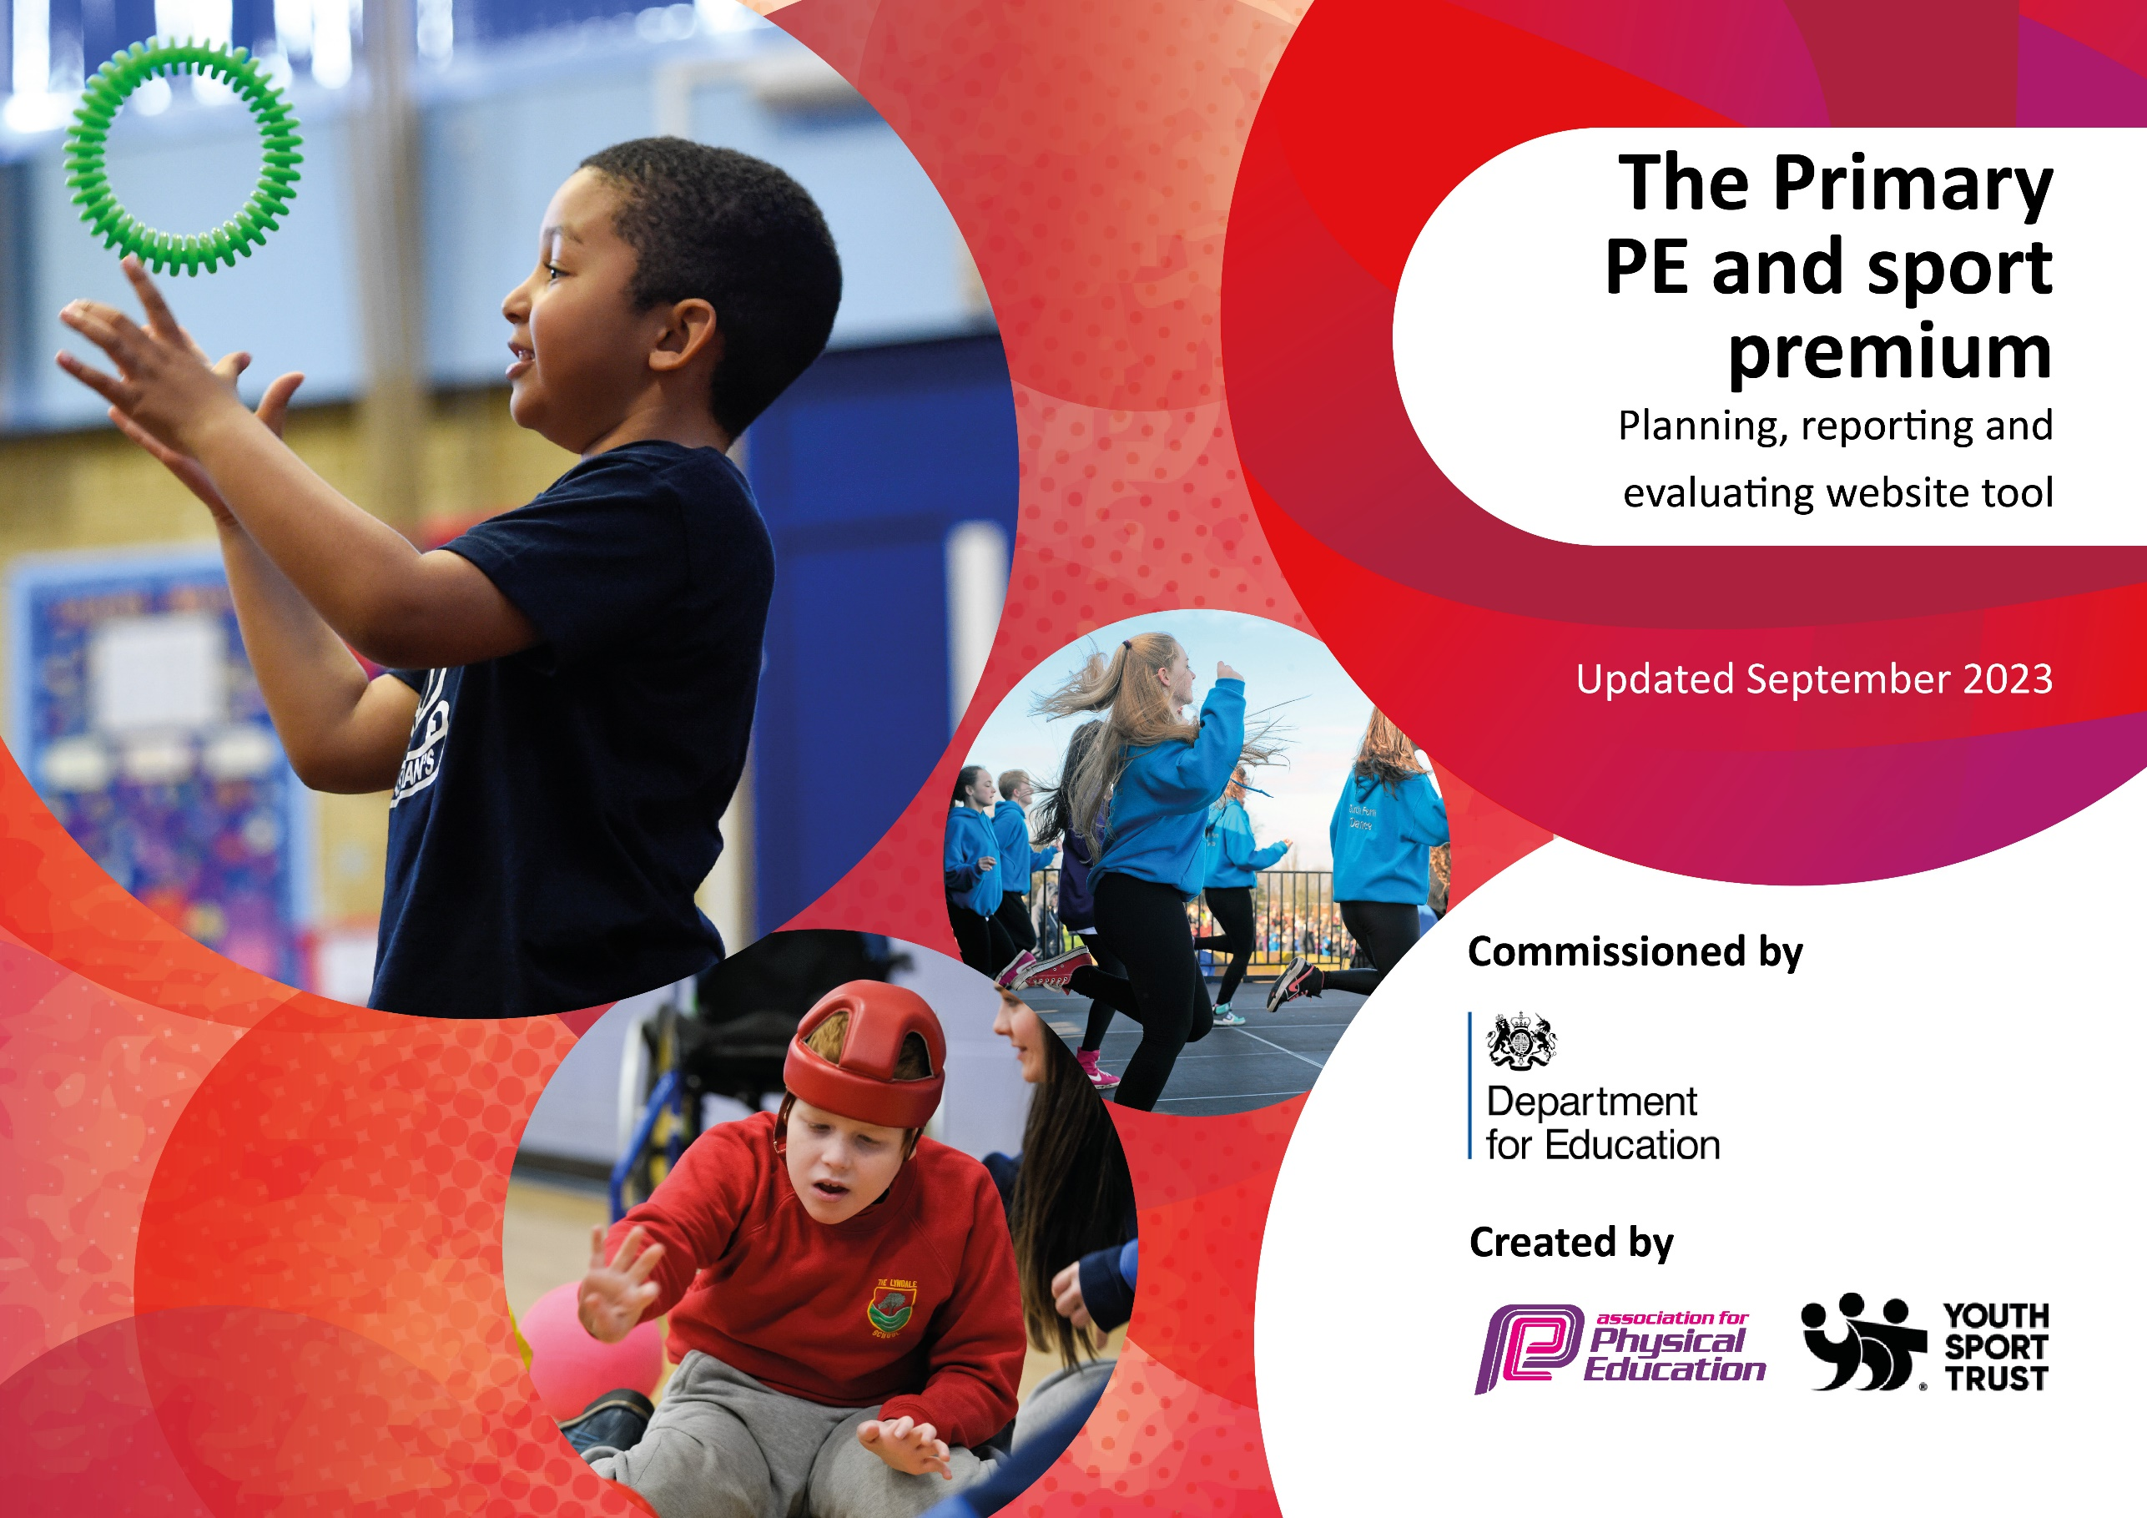

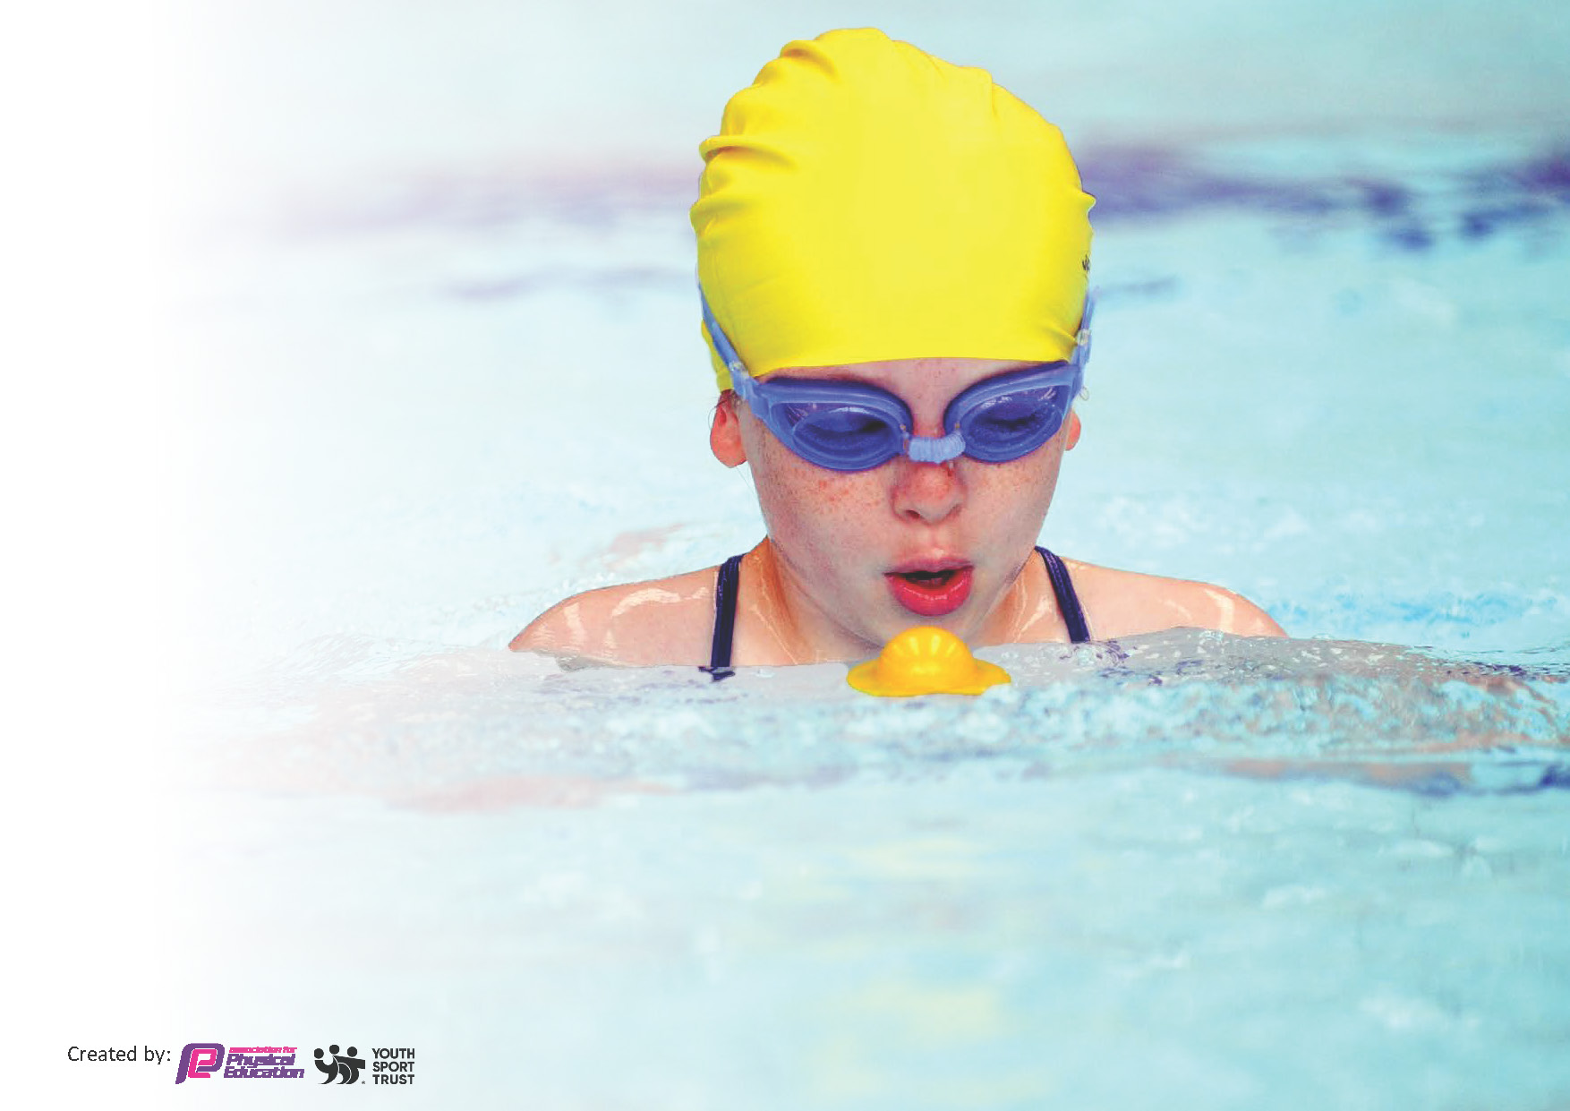
This template can be used for multiple purposes:
by:
- It enables schools to effectively plan their use of the Primary PE and sport premium
- It helps schools to meet the requirements (as set out in guidance) to publish information on their Primary PE and sport premium
- It will be an effective document to support Ofsted inspections enabling schools to evidence progress in Physical Education (PE) and evidence swimming attainment, which forms part of the PE National Curriculum. We would recommend schools consider
the Intent, Implementation and Impact of any spend, as examined within the Education Inspection Framework.

It is important that your grant is used effectively and based on school need.

Schools must use the funding to make additional and sustainable
improvements to the quality of the PE, School Sport and Physical Activity (PESSPA)
they offer. This means that you should use the Primary PE and sport premium to:

- Build capacity and capability within the school to ensure that improvements made now will benefit pupils joining the school in future years
- Develop or add to the PESSPA activities that your school already offers.

The Primary PE and sport premium should not be used to fund capital spend projects; the school’s core budget should fund these. Further detail on capital expenditure can be found in the updated Primary PE and sport premium guidance.

The Primary PE and sport premium guidance, outlines 5 key priorities that funding should be used towards. It is not

necessary that spending has to meet all the key priorities, you should select the priorities that you aim to use any funding towards.

Although completing this template is not a requirement for schools, schools are required to publish details of how they spend this funding. Schools must also outline what the impact this funding has had on pupils’ PE and sport participation and attainment and how any spending will be sustainable in the future. All funding must be spent by 31st July 2024.

The Department for Education has worked closely with the Association for Physical Education (afPE) and the Youth Sport Trust (YST) to develop this template and encourages schools to use it. This template is an effective way of meeting the reporting requirements of the Primary PE and sport premium.
Review of last year’s spend and key achievements (2022/2023)

We recommend you start by reflecting on the impact of current provision and reviewing your previous spend.

Activity/Action | Impact | Comments
Please read in association with Evidencing the Impact of Primary PE and Sport Premium July 2023 Update.  Total fund allocated: £18,881  - Partnership with Pennine Sporting Alliance has been established.  BHT physical music and dance summer / autumn 22-23 = £1400. Pennine Sports Dance summer 1 and 2 = £1260  - Sessions will be delivered by HTFC across three half terms (Autumn 1, Spring 1 & Summer 1) for children in KS1 and KS2.  Hudds Town ASC - football friday autumn 22 and spring term 23 = £528 Summer Term : £288  - Beyond the Physical PE Scheme introduced  - Bikeability carried out and booked again for next year.  - Swimming lessons for Y6.  - Project sport lunch coaches Spring 2 = £2100  Project sport Dance spring 1 and 2 = £1260  Transport costs over the year with taxi and coach= £450 | - Children took part in inter school competitions organized by PSP. Clubs were organized in school to allow for practice prior to these competitions.  A greater range of small clubs were therefore offered to children.  Dance coach ran an after school club for Y4 ,5 and 6 in Spring 1 and worked with Y2 in PE time to teach the children a dance who then performed at Lawrence Batley Theatre as part of Strictly Pennine.  Pennine staff have provided CPD to individual staff to promote CPD.  A Pennine dance/yoga coach delivered dance sessions and after school clubs during Spring 2 and Summer 2 to Year 3, 4, 5 and 6.  Pennine coach Kat (school coordinator) delivered ‘Active Reading’ session for Year 1 and 2 in Autumn 1 and 2.  Pennine coach Kat (school coordinator) undertook baseline PE data testing for Year 2, Year 4 and Year 6 in Autumn 1 and 2.  Pennine coach Kat (school coordinator) delivered training to 20 Year 5 children on play leading. We had 20 qualified play leaders who helped deliver sessions at lunchtime and at sporting events.  Play leaders delivered sessions to all KS1 children during Summer 2 with support from Pennine staff. (Summer 2)  A group of children from Y 4,5 and 6 took part in Sports Hall Athletics (Spring 1)  Y5 children took part in Pennine Cricket Competition and qualified for Kirklees finals. (Summer 1)  Y5/6 children took part in Pennine Rounders competition (Summer 2)  All Y4 children took part in National Sports Week and spent at day at Leeds Road Sports Complex – organised by Pennine.  Three children from Y5/6 took part in the Pennine Sports Awards at the Town Hall and were awarded certificates for their contributions to school sport.  All children in KS1/KS2 had Tennis coaching from Longley Tennis Club (Summer 2)  - HTFC coach has been working with staff in Y1,Y2,Y3 and Y4 in the Autumn, Spring and Summer terms to help deliver PE sessions and provide CPD.  A team from Year 5 and 6 took part in the EFL Kids Cup organised by HTFC.  Y4 children have taken part in the Primary Stars Football Competition.  HTFC have led an after school football club every Friday (Autumn 2, Spring 1, Spring 2, Summer 1 and Summer 2)  HTFC have led sessions in school every Tuesday all year. This has included working with Y5/6 on the Primary Stars Campaign.  HTFC have also led sessions with Y3 children on the Planet Super League Campaign.  Children in KS2 have taken part in promotional activities with HTFC.  - Beyond the physical planning used and progression and ideas for games and skills improved with focus on game skill rather than game name.  Staff supported with ideas and strategies given within the planning and from the supplementary videos.  - Bikeability ensured that children in Y5 who didn’t have the skills could learn to ride a bike. Children were also taken out onto the local roads to achieve their level 3.  - Swimming:  - Project Sport led lunch time activities – small impact made, see comments. | - PSP to continue and for the school to take part in inter school competitions. No need for baseline assessment as we move to school based assessment statements based on the National Curriculum. Continue with play leader training and PSP staff attend school to offer support sessions with children and lead classes with school staff gaining CPD from observations.  - Links with HTFC to be made stronger next year with further spending on coaches to support staff and clubs in school. This will be linked to Regular monitoring of number of pupils attending an extra-curricular club. This will be done through the Spiral PE Platform/School Spider, as stated in July 2023 update.  - Beyond the Physical to be used with further evidence of adaptation to lessons for children with need.  - Bikeability to be run again in school.  - Swimming to be monitored with a view to early school years attending and trying to get away from Y6 going swimming to hopefully have Y4 accessing swimming by Sept 26.  - Project Sport link to be paused with a favour of working with HTFC.

Key priorities and Planning
This planning template will allow schools to accurately plan their spending.

Action – what are you planning to do | Who does this action impact? | Key indicator to meet | Impacts and how sustainability will be achieved? | Cost linked to the action
Continue to utilize and deliver PE based on the Beyond the Physical planning.  The focus this year will be on adaptation of planning and games/activities taught to ensure all pupils are engaged and skills are developed. Further work will be given to looking at assessing PE formally, either using BTP or the KPI’s via O’Track. | Children: All children will access PE at a level suitable to them. All children will learn skills and progress and succeed in PE skills and knowledge. Lessons will be adapted so children are challenged and suitable goals are given and adapted.  Teachers: Staff will have training on adapting lessons for all learners and have the assessment tool explained and how to complete. Staff will also be supported with HTFC delivering lessons and team teaching with staff to encourage quality CPD. | - Increased confidence, knowledge and skills of all staff in teaching PE and sport  - The engagement of all pupils in regular physical activity  - The profile of PE and sport is raised across the school as a tool for whole-school improvement | All children will be engaged and be able to advance and build on skills in lessons by staff adapting lessons to support all learners.  Staff will assess PE to ensure progress of skills is measured throughout school using O’Track/BTP to inform furture planning and next year teaching.  Staff will be confident in setting up and organising games and skills within the PE lesson and have strategies and ideas on how to develop positive conversation and incorporate correct terminology and vocabulary with the children using BTP planning.  Staff will initially work under direction of HTFC Foundation team and move to begin to lead sessions with HTFC Foundation coach supporting and team teaching. Staff will move to delivering the session in collaboration with HTFC Foundation coach. | £475 (£495 financial year Apr 24-25)
Action – what are you planning to do | Who does this action impact? | Key indicator to meet | Impacts and how sustainability will be achieved? | Cost linked to the action
Provide a greater range of after school clubs with some building up to inter school competitions organized by PSP.  Run further clubs each night provided by HTFC Foundation.  Transport to sporting events. | Staff to ensure children are given a range of clubs in which they can access after school.  SLT will reward staff with half a day cover to encourage further free after school clubs.  PE lead to publicise the inter school competitions so staff can work towards these with the children.  Children will have the opportunity to access a greater range of activities and have the opportunity to play sport against other schools in the local area.  The aim is to have a focus for the club and something to work towards. | - The engagement of all pupils in regular physical activity  - The profile of PE and sport is raised across the school as a tool for whole-school improvement  - Broader experience of a range of sports and activities offered to all pupils  - Increased participation in competitive sport | 50% of children will access an after-school sports club during the school year.  60% of PP children will access an after-school club.  Children will be able to play sport against children from other educational establishments via PSP links.  SLT will encourage staff to provide clubs with incentives of 0.5 day release.  Continued work with PSP will ensure sustainability will be achieved.  HTFC Foundation will provide additional clubs and this will be linked to HTFC and Pennine events. | £1500  (Cost from Nov- March for taxis = £174)  (Pennine Sports Dance tutor for Summer ½ carried over to Nov 23 = £1260)

Action – what are you planning to do | Who does this action impact? | Key indicator to meet | Impacts and how sustainability will be achieved? | Cost linked to the action
Work closely with HTFC sports coaches to provide support within lessons and provide a greater range of after school clubs. | HTFC community coaching staff will support Y5 through Primary Reading Star interventions to focused Y5 children and support Reception’s staff to deliver quality PE lessons to receptions children using he BTP planning.  In the afternoon sessions: HTFC community coaching staff will support KS1 and 2 PE lessons. They will deliver, team teach and support staff to deliver BTP planning to a high standard.  After school: HTFC community coaching staff will deliver a range of after school clubs in addition to the ones offered by school staff. Coaches will also support to access school competitions through the HTFC sports programme. Some of these sessions will also support the Pennine Sports Partnership events. | - Increased confidence, knowledge and skills of all staff in teaching PE and sport  - The engagement of all pupils in regular physical activity  - The profile of PE and sport is raised across the school as a tool for whole-school improvement  - Broader experience of a range of sports and activities offered to all pupils  - Increased participation in competitive sport | Staff will deliver high quality PE and after school clubs. As seen from observations.  Staff will feel confident in delivering BTP PE lessons as seen via staff voice.  Staff will assess the skills by pupils in PE using O’Track or BTP.  Staff skills will be discovered and developed to ensure after school clubs can flourish in the near future.  Children’s reading and confidence will be developed and promoted via the reading scheme. | £18,000  (April 24-25 financial year, £20,000)

Action – what are you planning to do | Who does this action impact? | Key indicator to meet | Impacts and how sustainability will be achieved? | Cost linked to the action
Maintain links with Pennine Sports Partnership. | Working with PSP will allow us to set up Y5 play leaders to support active lunchtimes using range of activities to help keep children active.  It will also allow us to be able to play inter school sport competitions and access Georgia’s skills to deliver session in school for children and staff CPD.  Entrance to Strictly Pennine to allow children to perform in Huddersfield at the Lawrence Batley Theatre.  Y5 access bikeability so learn to ride a bike and ride around in their local community. | - Increased confidence, knowledge and skills of all staff in teaching PE and sport  - The engagement of all pupils in regular physical activity  - The profile of PE and sport is raised across the school as a tool for whole-school improvement | Children will be able to run activities for others and support lunch time staff via the play leader training and monitoring.  Lunch-time behaviour will improve and the children’s participation in sport and exercise will increase as monitored by SLT and lunch staff.  Children will be able to play against other schools organised by PE lead and PSP.  Staff confidence in certain areas of PE, namely gym and dance will be improved via support session and staff meeting time.  Children can perform in their community on a stage at a fully organized and semi-public event via Strictly Pennine.  Children will learn to ride a bike and be safe on the roads. This facility will be accessed every year. | £2044 (£2050 set aside for financial year April 24-25)

Action – what are you planning to do | Who does this action impact? | Key indicator to meet | Impacts and how sustainability will be achieved? | Cost linked to the action
Y6 attend baths to access swimming lessons provided by KAL.  Plan to alter so less Y6 go swimming in future and younger children in school access swimming as a regular PE session. | Y6 children so they can learn to swim and learn survival and life support skills. | - The engagement of all pupils in regular physical activity  - The profile of PE and sport is raised across the school as a tool for whole-school improvement  - Broader experience of a range of sports and activities offered to all pupils | Children will leave school being able to swim 25m unaided and have some water survival skills. | £11,500
Total sports premium income 23/24 = £18,940

Key achievements 2023-2024
This template will be completed at the end of the academic year and will showcase the key achievements schools have made with their Primary PE and sport premium spending.

Activity/Action | Impact | Comments
Penine Sports Partnership Conference  19.9.23  Y5/6 Football Tournament at HNC 6 a side  Play leader training 5.10.23  Y5 Bikeability wb:16.10.23  Y1/2 Boccia Tournament at NHT 28.11.23  KS1 Inclusion Festival at St Joseph’s School organized by PSP.  Girls Football Tournament at Leeds Road Complex  KS1 Multi skills event organized by PSP.  EFL Kids Cup U11 (Y5 & Y6) National Football Tournament organized by HTFC  Y56 girls football event at Leeds Road. Our girls representing HTFC.  Y3 dance in school led by Georgia from Pennine.  Y3/4 catch and pass event at NHT  Strictly Pennine at Lawrence Batley Theatre.  Y4 dance in school led by Georgia from Pennine.  Y5/6 girls football event at NHT  U11 Moldgreen Rugby club visited school to lead an assembly with KS2 and take session with Y5.  Big Football session.  Show racism the red card  Y5/6 girls football team to attend John Smith’s Stadium for tour in recognition of representing the club at the regional event in Feb.  Governor Day 21.3.24  25.4.24 Georgia from Pennine to deliver exercise to music sessions for reception helped by play leaders.  25.4.24 Georgia took Boccia sessions with Y2 children with play leader support. | Meet PE leads.  Learn calendar dates  Meet Georgia Davison Penine Link PE Lead  6 Y5/6 boys attended and won 2 games and drew 1.  13 Y5 play leaders have been trained to lead and organize games at lunch times.  Calmer lunches. Equipment being used correctly.  Children learnt to ride a bike and children went cycling on the local community roads to achieve level 3 bikeability awards.  5 Y1/2 children attended the tournament, 2 boys and 3 girls.  6 children from KS1 attended this event. Children who don’t normally interact with others easily were able to play sport in a safe and new environment.  9 girls took part and won the event. Through to regional finals.  Georgia worked with the playleaders and lead activities for KS1 children all day. Each class had 1 hour to work on a variety of skills.  8 Y5/6 boys took part in this tournament at Leeds Road Complex. Showcasing skills and being noticed for playing skills by HTFC.  9 girls took part and came 4th in the region.  Each class had a 1 hour session  8 children took part.  12 girls from Y5/6 took part.  Each class had a 1 hour session.  10 girls took part.  Each Y5 class had a 40 min session.  Only girls on the MUGA  Y 5 attended  9 girls attended.  Two governors were able to speak to the PE lead and the PE lead could cascade a lot of information to the governors for greater awareness of PE in school.  Children in reception experienced a movement to dance session led by a trained PE coach and the playleaders gained experience of working with youngsters and engaging in a high quality lesson.  Y2 received high quality Boccia lesson with Y5 support. | The impact of the external partnerships has been seen across the school.  There has been a huge take up on girls participating in football with the team winning the Huddersfield’s school competition.  Having the opportunity to perform at a local theatre gave pupils confidence and a unique opportunity. Pupil voice was extremely positive.

Swimming Data
Meeting National Curriculum requirements for swimming and water safety.
Priority should always be given to ensuring that pupils can perform safe self-rescue even if they do not fully meet the first two requirements of the National Curriculum programme of study

Question | Stats: | Further context  Relative to local challenges
What percentage of your current Year 6 cohort can swim competently, confidently and proficiently over a distance of at least 25 metres? | % | Increase over 71%
What percentage of your current Year 6 cohort can use a range of strokes effectively [for example, front crawl, backstroke, and breaststroke]? | % | Increase over 29%

What percentage of your current Year 6 cohort are able to perform safe self-rescue in different water-based situations? | % | Increase over 21%
If your schools swimming data is below national expectation, you can choose to use the Primary PE and sport premium to provide additional top-up sessions for those pupils that did not meet National Curriculum  requirements after the completion of core lessons. Have you done this? | Yes/No
Have you provided CPD to improve the knowledge and confidence of staff to be able to teach swimming and water safety? | Yes/No

Signed off by:

Head Teacher: | Mrs H Pearson
Subject Leader or the individual responsible for the Primary PE and sport premium: | Mr C Simeson
Governor: | Anthony Briggs
Date: | Summer 2024.

